**How to Write, Compile, and Run Java Programs on Mobile**

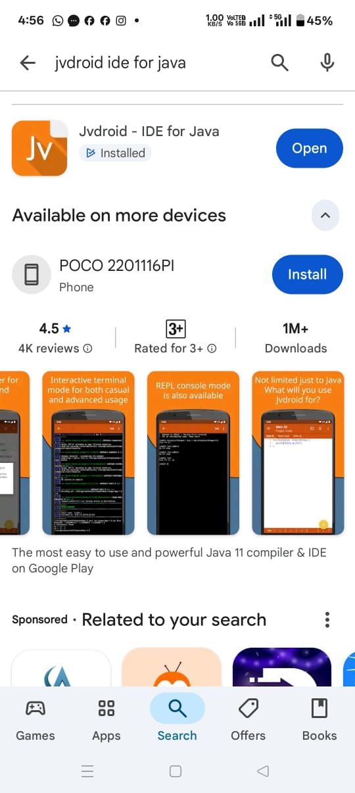**🟢 For Android Students**

1. **Install an App**
   * Open **Google Play Store**.
   * Search **“Jvdroid – Java IDE”** (best free Java app).
   * Install it.
2. **Open the App**
   * You will see an editor screen.
3. **Type Your First Program**
4. class Hello {
5. public static void main(String[] args) {
6. System.out.println("Hello, Java from Mobile!");
7. }
8. }
9. **Run the Program**
   * Press the **▶ Run button** (triangle shape).
   * Output will appear at the bottom.
10. **Common Tips**
    * Use { } brackets carefully.
    * Always end a line with ;
    * Save your work in the app.

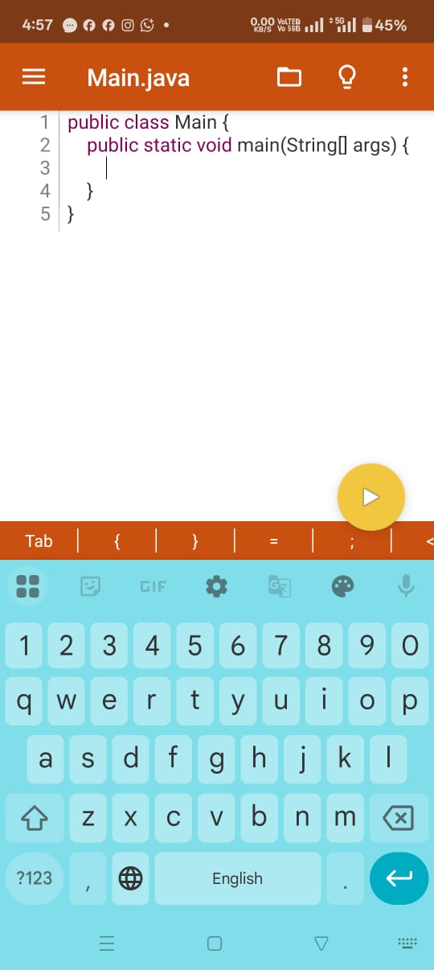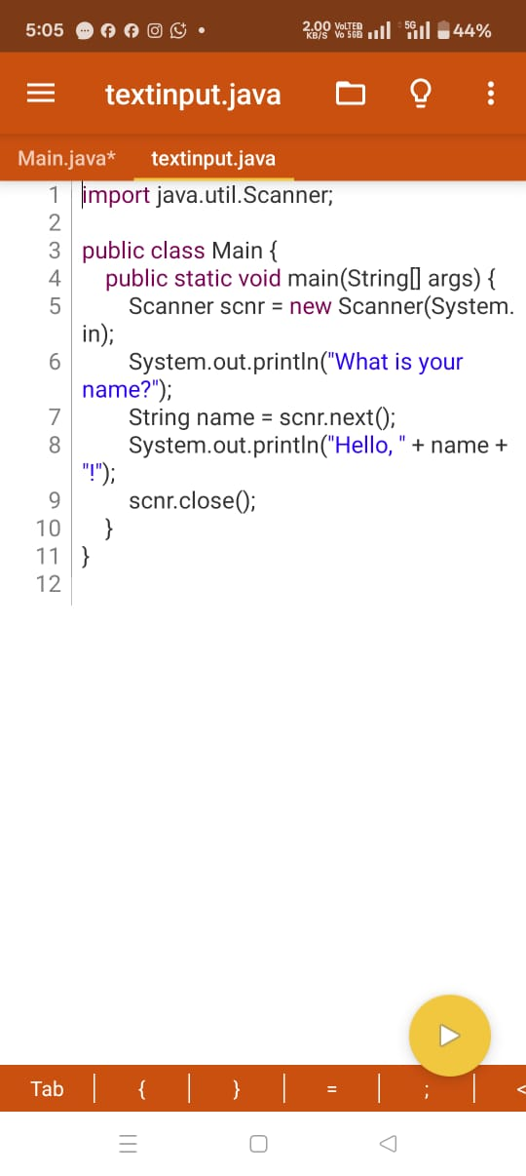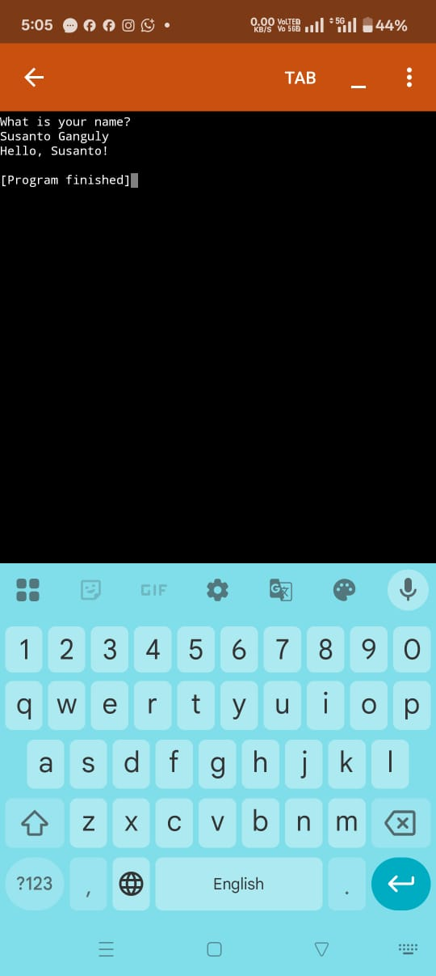

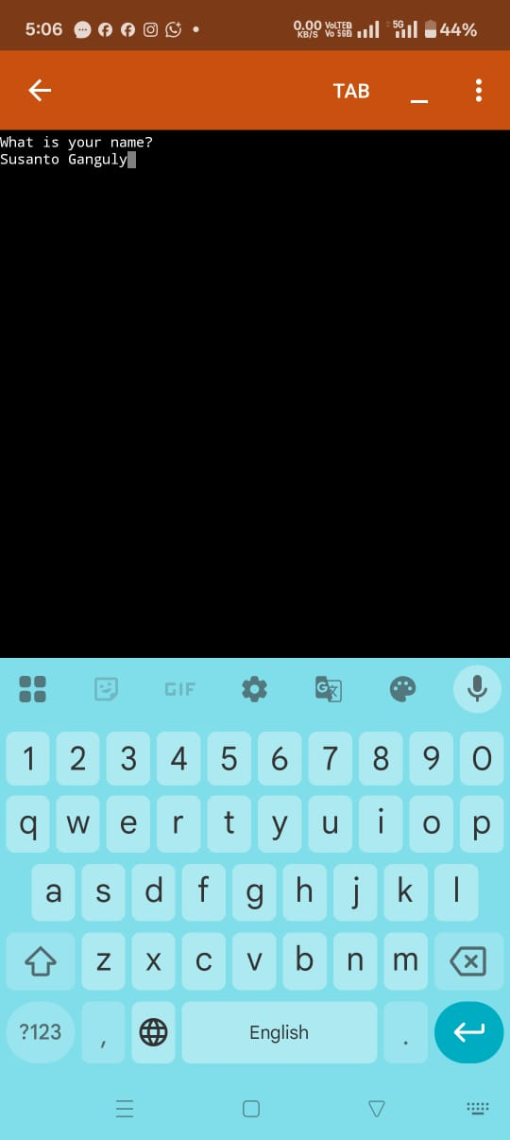

**🔵 For iPhone (iOS) Students**

1. **Install an App**
   * Open **App Store**.
   * Search **“Java N-IDE”** or **“Programming Hub”**.
   * Install it.
2. **Open the App**
   * Tap **New Project → Java**.
3. **Write a Program**
4. class Hello {
5. public static void main(String[] args) {
6. System.out.println("Hello, Java from iPhone!");
7. }
8. }
9. **Run the Program**
   * Tap the **Run button**.
   * Output will show on screen.

**📖 General Rules for All Students**

* Always write programs inside a **class**.
* The main method must be:
* public static void main(String[] args)
* Output comes using:
* System.out.println("Your Text");
* If you see an **error message**, read it slowly → usually a spelling mistake, missing ;, or wrong brackets.

**✅ Practice Plan on Mobile**

* First run **Hello Java**.
* Then type the **20 beginner programs** (from earlier).
* Change the numbers and see how the output changes.

👉 This way, students can **learn Java fully on mobile** without a computer.

Would you like me to also create a **one-page printable handout (PDF style)** with these steps (with screenshots for Android + iPhone apps), so you can distribute it in class?

Here’s a **student-friendly guide** you can give directly to your class. It explains **how to write, compile, and run Java programs on mobile phones** step by step.

**📱 How to Run Java Programs on Mobile (Android & iPhone)**

**🟢 For Android Students**

1. **Install an App**
   * Open **Google Play Store**.
   * Search and install **“Jvdroid – Java IDE”** (free and easy).
2. **Open the App**
   * You will see an editor screen (like a notebook).
3. **Type Your First Program**
4. class Hello {
5. public static void main(String[] args) {
6. System.out.println("Hello, Java from Mobile!");
7. }
8. }
9. **Run the Program**
   * Tap the **▶ Run button** (triangle).
   * Your output will appear at the bottom.

**🔵 For iPhone (iOS) Students**

1. **Install an App**
   * Open **App Store**.
   * Search and install **“Programming Hub”** or **“Java N-IDE”**.
2. **Open the App**
   * Create a new Java file/project.
3. **Write the Program**
4. class Hello {
5. public static void main(String[] args) {
6. System.out.println("Hello, Java from iPhone!");
7. }
8. }
9. **Run the Program**
   * Tap the **Run button**.
   * Output will show on the screen.

**📖 Rules to Remember (For All Students)**

* Every Java program must be inside a **class**.
* Always include the **main method**:
* public static void main(String[] args)
* Use **System.out.println("Text");** to print output.
* End each line with a **semicolon (;)**.
* If an error comes:
  + Check spelling
  + Check { } brackets
  + Check missing ;

**✅ Practice Plan on Mobile**

* Step 1: First run **Hello Java**.
* Step 2: Then try the **20 simple programs** (name, bio-data, add, subtract, etc.).
* Step 3: Change the numbers in the program → see how output changes.
* Step 4: Try to type without looking at the notebook.